

**GEOG 390 / GEOG 660**

**Lab 2 – Managing Vector & Raster Data**



**Name: Jonathan Janzen**

**Date: September 11, 2019**

**Section: 505**

**Ch. 5 Tutorial Questions**

***\*All screenshots should have the Map Scene window and Contents Pane (with symbology for all visible layers shown). Refer to Figure 3 in Lab 1’s instruction document.***

**Begin tutorial on page 161**

1. **Question 1 (after step 1.4)**: Since empty spaces are not recommended/allowed when naming files and folders in ArcGIS Pro, what symbol can be used to separate words in these situations? Are spaces allowed for Layer names in the Contents Pane and the Map Scene’s name (yes/no)?

**Symbol to use:** _ (aka underscore)

**yes/no:** yes

1. **Question 2 (after step 2.7)**: Navigate to the *BlackHills* folder in *mgisdata* using Catalog View. How many of each datatype type are located in this folder (do not go into the Downloads folder or the geodatabase)? Provide the number of each below (if none are present put 0, and ignore the Raster and Task files). Use Table 5.1 on pg. 154 for guidance.

**Shapefiles:** 3

**Coverages:** 0

**Geodatabases:** 1

**Database Connections:** 0

**Layer Files:** 5

**Tables:** 0

**TINs:** 0

**CAD Drawings:** 0

1. **Question 3 (after step 20.2)**: Even if you may not share data you create, is having Metadata still important? Explain why (3-5 sentences)? Use Ch. 5 and lecture notes to help answer this question. If using the internet, use proper citations of sites where you found your information.

**Explanation (3-5 sentences):**

First and foremost, adding metadata to data that are not going to be shared ensures that the data will be reusable. By adding metadata, the user can remind themselves of what uses the data may have, and especially details relating to the accuracy and precision of the data. It may be hard to remember what the data were originally for far into the future. Additionally, adding metadata to data establishes good practices for data that IS shared with others. That is, it provides a way to practice and establish proficiency.

1. **Question 4 (after step 22.2)**: What is the key difference between the two Clip tools (1-2 sentences)? Which one is the correct one for this case? Is it possible to convert a vector dataset into a raster (yes/no) (hint: Geoprocessing > Toolboxes > Conversion Tools > To Raster)? How about from raster to vector (yes/no) (hint: Conversion Tools > From Raster)?

**Difference between two Clip tools (1-2 sentences):**

“Clip (Analysis Tools)” is used to clip vector data. On the other hand, “Clip (Data Management Tools” is used to clip raster data.

**Correct Clip tool to use:** Clip (Analysis Tools)

**Possible to convert Vector to Raster (yes/no):** yes

**Possible to convert Raster to Vector (yes/no):** yes

1. **Question 5 (after step 23.4)**: Why do the districts and the state boundary have different boundaries? Why is the state boundary so different from the basemap boundary for New Jersey? Use Ch. 5, lecture notes, and the internet to help answer this question (3-5 sentences). Take ONE screenshot in an area where the state boundary is noticeably different from the districts and basemap’s (be sure to provide the location your image represents, what each line represents, and what Basemap you are using in your caption), work with transparency and color so all three features can be seen.

**Explanation (3-5 sentences):**

The state and the districts have different boundaries because the data are used for different purposes. For the “njbound_gen” layer the source is from data that covers the entire United States. It’s reasonable, then, that the data do not contain high resolution boundaries for tiny details of each state. On the other hand, the “njdistricts” layer is derived from data about the individual districts for political campaigning. Because of the different purpose, this data has much higher resolution as the data are for determining which houses can vote for which politicians. This map must account for all of the little oddities of natural geography because citizens live all over the map. In short, the njbound_gen map is lower resolution, and the njdistricts is higher. See the captioned picture for an example.

**Insert captioned screenshot below:**

The below picture shows that njbound_gen (shown in red) does not fully represent the geometry of the state boundary. On the other hand, the njdistricts (shown in green) layer is much closer to reality.

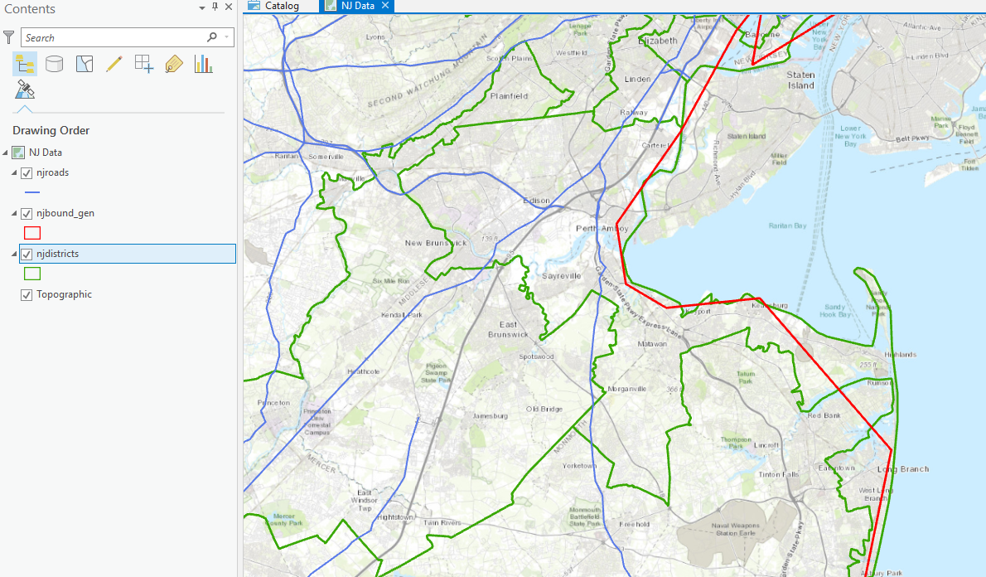

1. **Question 6 (after answering question 5)**: Open a new Map Scene. Add *njbound_gen* and *njdistricts* to the Contents pane. Use the Clip (Analysis Tools) tool. Set *cd114* as the Input Feature and *njbound_gen* as the Clip Feature. Name the Output *cd114_state_clip*. Run the tool.

What has happened to *cd114*’s boundaries (especially along the coast)? Why would this be a problem? (3-5 sentences)

Provide a captioned screenshot (include Contents Pane) of the original *cd114* layer with *cd114_state_clip* above it (turn all other layers off). Make sure the layers haves contrasting colors.

**Explanation (3-5 sentences):**

The problem is especially prevalent on the coast: some districts are cut off because the njbound_gen layer’s resolution is too low. Since the clip tool updates the boundaries of polygons to always be within the clip boundaries, we lose some data. This can be fine in some cases, but in this particular case it means that we are excluding some voters! If the use case is political polling the pollster would misrepresent those districts. This can be more harmful if the cd114_state_clip layer we produced is used as the official voting map as those citizens would be excluded from the vote.

**Insert captioned screenshot below:**

The below screenshot shows that (especially on the coastline) the layer cd114_state_clip is not accurate. The blue line shows the original njdistricts layer and the red line shows the new, and inaccurate, cd114_state_clip layer.

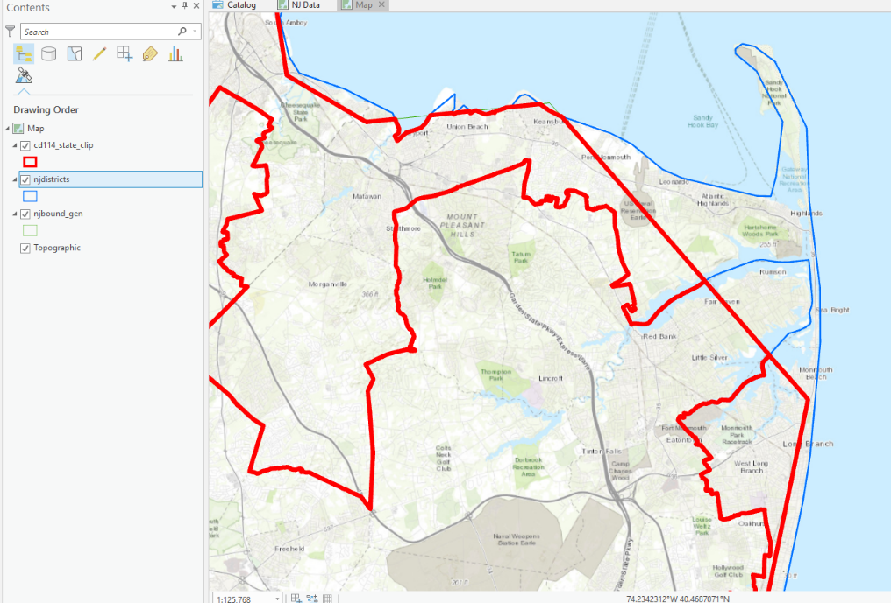

1. **Question 7 (after step 35.3):** What is the purpose of the golf courses dataset according to the Metadata? How many golf courses does this shapefile have?

**Purpose of dataset:** “provide information for the Source Water Assessment Program (SWAP) to estimate the acreage and location of golf courses throughout the state.”

**# golf courses:** 258



**Ch. 5 Practice Exercise**

1. Choose any state (except New Jersey)
2. Create a new project and name it after your chosen state. Save it in the *gisclass*/Projects folder.
3. Export each of the vector feature classes from the *usdata* geodatabase to your project’s geodatabase, taking care to export only the features classes with data in your state.
4. Update the Item Description for each data set exported.
5. Use the All Portal feature or search online for at least TWO additional feature classes for your project’s geodatabase that you find interesting. Import them to the geodatabase as well.
6. Arrange the layers in Contents appropriately (remember to consider transparency, color, size, and symbolization). If the map is too cluttered, turn off some layers.
7. Compile the following items on the following page:
   1. *A captioned screenshot for each updated Item Description (# feature classes exported from usdata geodatabase).*
   2. *ONE captioned screenshot of your Map Scene with all layers used (arranged and symbolized appropriately), include the Contents Pane.*
   3. *ONE captioned screenshot of your Map Scene, include the Contents Pane, with only the internet data layers turned on (acquired from All Portal or Internet).*
   4. *Below your screenshots, include a list of proper citations for each dataset*

(See last page of report)



**Ch. 6 Tutorial Questions**

**Begin tutorial on page 192.**

1. **Question 1 (after step 5.1):** According to the Metadata section of *dem30m*, what does NED stand for? List TWO disciplines that the NED can be used for (look in Summary section). What is the area (with correct units) of a single pixel in the dem30 raster (hint: look in Source > Raster Information)?

**NED =** National Elevation Dataset

**2 Disciplines:** E.g. Global Change Research & Hydrologic Modeling

**Pixel Area =** 30 * 30 = 900

1. **Question 2 (after step 6.6):** Sort the Count field in descending order. Which Value occurs most frequently (by a factor of 10)? Provide the Value and Count numbers (do not include commas). What feature is mostly comprised of this Value?

**Value:** 180

**Count:** 573542

**Feature:** The surface of the lake is 180

1. **Question 3 (after step 10.4):** Now that you know how to assign specific bands. Play around and see what different combinations look like. Attach ONE screenshot of your most interesting CUSTOM band combination (don’t do 3-2-1, 4-3-1, or 7-4-1). Caption your screenshot with the band combination and what features are most visible (include associated color).

**Insert captioned screenshot here:**

In the following screenshot of crater lake, band 6 is used for red, band 5 is used for green and band 7 is used for blue.

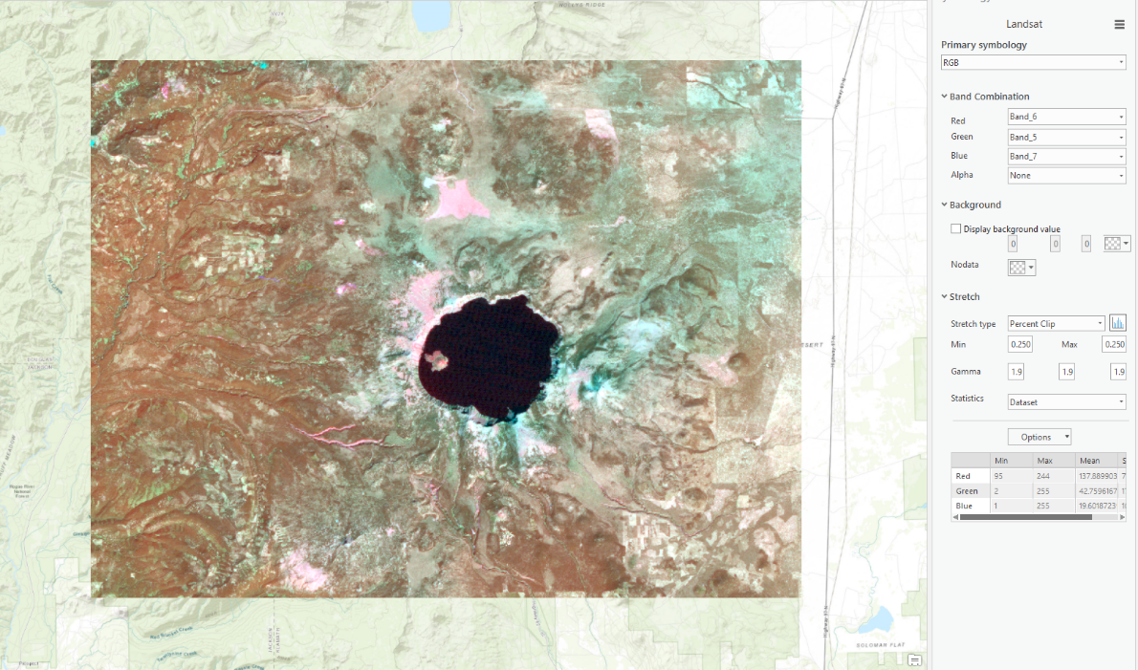

1. **Question 4 (after step 13.3):** Which rock unit (give both Count (do not use commas) and RockType) is most abundant at Crater Lake? The least abundant?

**Most abundant:** Ignimbrite with 148903

**Least abundant:** Sedimentary with 64

***\*Skip steps 22-35***

***\*Complete steps 36-37***

**When finished, save the Response Template as a PDF and upload it to Lab 2’s Assignment Dropbox on eCampus.**

**Chapter 5 Practice Exercise Writeup:**

I selected California for my state:

**A. Updated Item Descriptions:**

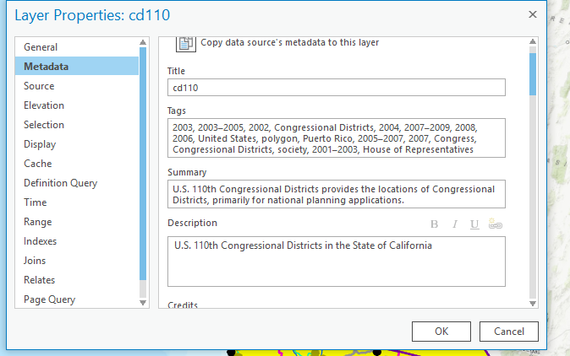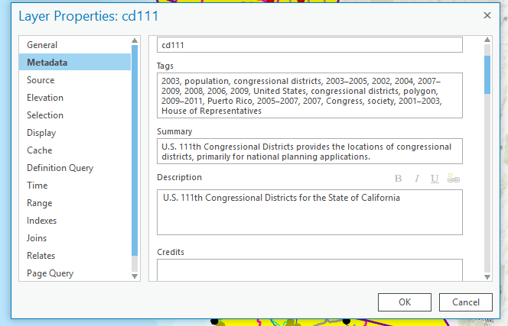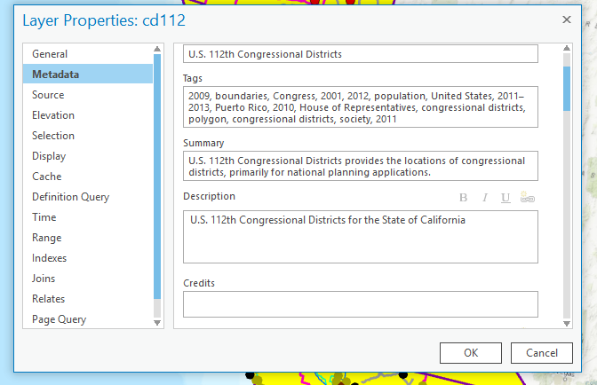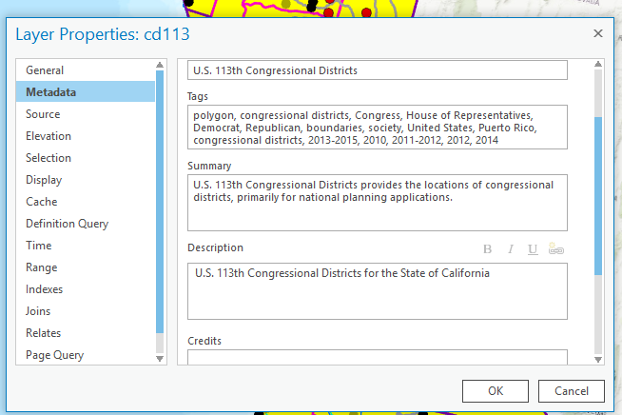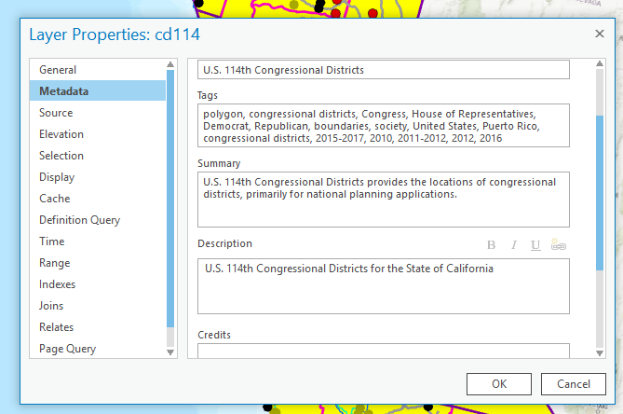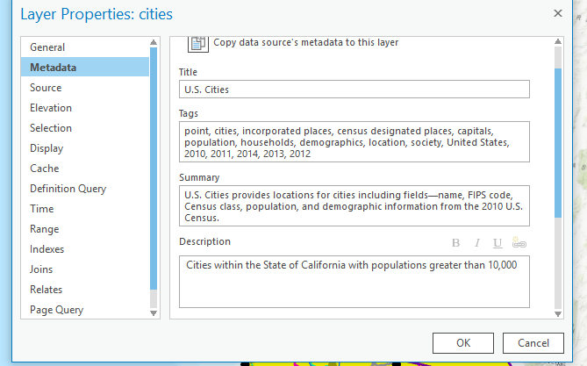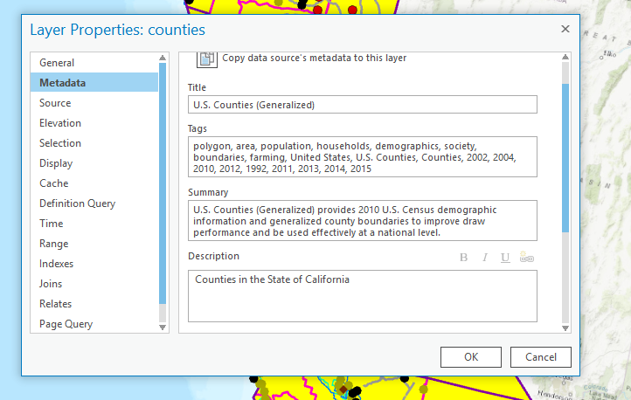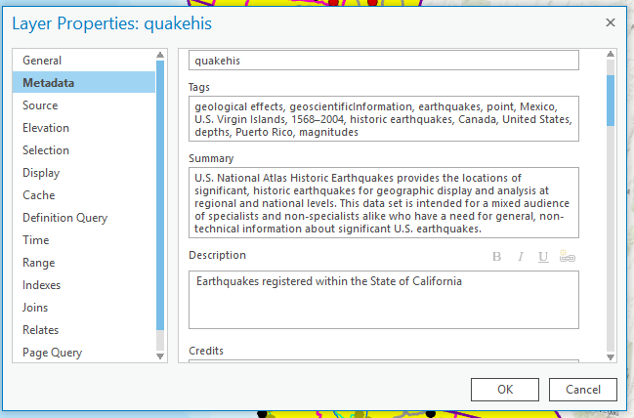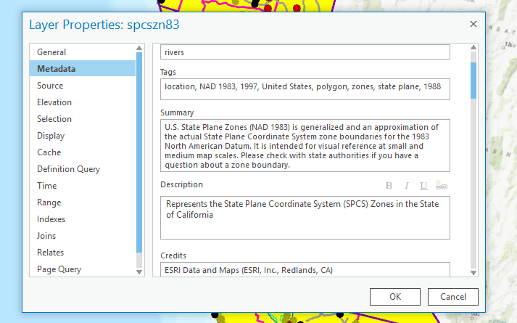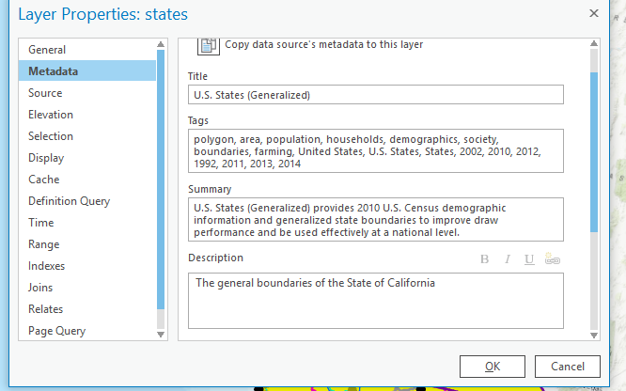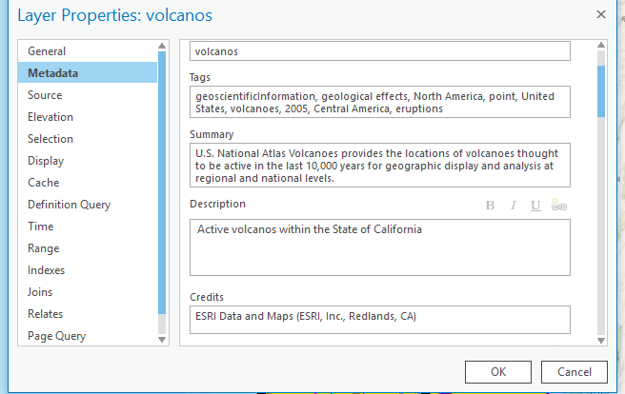

**B. All Layers:**

Here you can see an annotated map of California (highlighted in Yellow). Please see legend for more details on exact layers

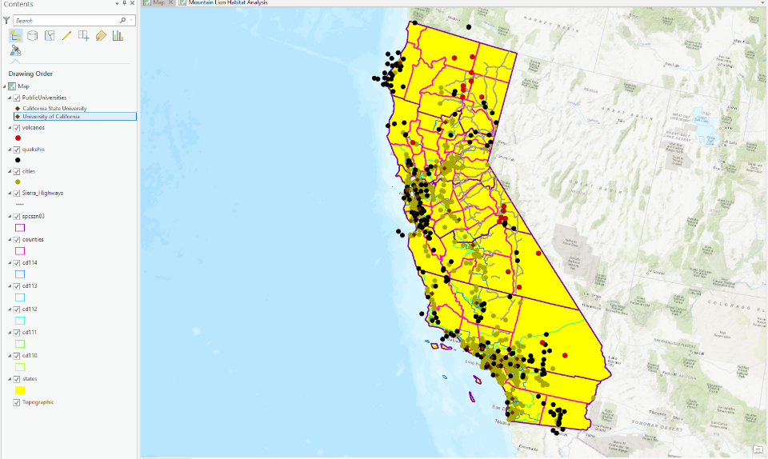

**C. Portal Layers:**

The below picture shows 2 layers: public universities (brown points) and the highways in the Sierra Mountain Range (grey lines).

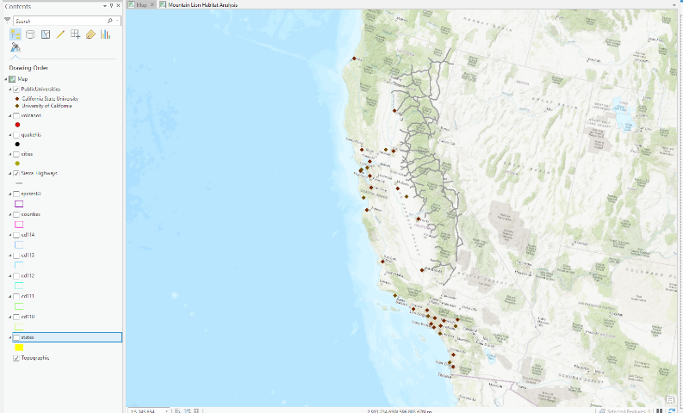

**D. Works Cited:**

Usdata (2018) [file geodatabase]. Price, M.H. Mastering ArcGIS Pro First Edition (tutorial data) mgisdata\Usa\usdata.gdb, [09/11/19]

Public Universities in California (2019) [feature service]. Esri https://services1.arcgis.com/4yjifSiIG17X0gW4/arcgis/rest/services/CA_public_universities/FeatureServer [09/11/19]

Sierra_Highways (2019) [feature layer] Mountain Lion Habitat Analysis, USGS, USDA, UC Davis, CCED, CPAD, NCED, NASA, Caltrans, CDFW, US EPA, Data Basin website https://tamu.maps.arcgis.com/home/item.html?id=e5c6238ce6ea480f86f69385b93f99f7